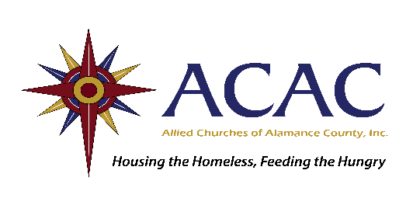

Thank you for supporting ACAC!

WHAT WE ALWAYS NEED
- pasta and red sauce (plastic or cans)
- paper towels/napkins
- canned meat
- seasonings (i.e., garlic powder, onion powder, lemon pepper, etc.)
- breakfast items (oatmeal, grits, granola bars)
- cutlery sets with a knife

OTHER ITEMS WE USE REGULARLY

- Personal care items such as deodorant, razors, soap and shampoo (retail size)

- Drink mix to serve in Joe’s Diner
- Plastic utensils, napkins, and wrapping films for our meal service
- Ground coffee, sugar, and creamer
- Grocery, discount store, gasoline and LINK Transit gift cards

HOUSEWARES needed for Residents moving out

We only accept NEW items:
- Basic pots and pans
- Dishes and cups (no cracks or chips)
- Glasses (no alcohol logos please)
- Flatware and serving/cooking utensils
- Twin, full and queen size sheet sets
- Pillows
- Washcloths and towels
- Basic household cleaning supplies-unopened, such as cleaner, paper products, etc.
(continued on back)
We can’t accept the following items at ACAC, but we would love for you to donate them directly to our partners, which distribute them to our clients in need free of charge:

First Presbyterian Church Furniture Ministry – (336) 212-2937
- Furniture
- Full, king, or queen sized linens
- Small appliances

Salvation Army Thrift Store – 3720 South Church Street- (336) 350-7447
- Clothing in good, clean condition
- Shoes

We cannot use:
- Clothing
- Furniture
- Large appliances
- Partially consumed food / leftover food of any kind
- Electronics
- Computers (unless new)
- Computer printers
- Stuffed animals or toys
- Lamps, vases, framed artwork, and other home accessories
- Mattresses or box springs
- Crutches, walkers, wheelchairs, or medical items

Donations can be dropped off at ACAC (206 N. Fisher St. Burlington) Monday through Friday from 9:00am – 5:00pm. Please enter through the marked door facing Trade St.
Questions? Email Sabrina at scorbett@alliedchurches.org or call (336)229-0881 x 102

